The High Life of Vermeer and his Contemporaries
Vermeer and the Masters of Genre Painting reinserts Vermeer into the tradition in which he worked, both demystifying his paintings and lending force to his particular take on the genre.
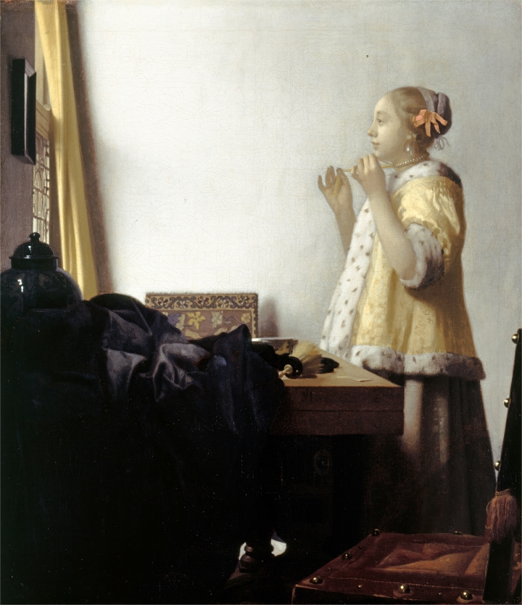Johannes Vermeer, “Woman with a Pearl Necklace” (c. 1662-65), oil on canvas (image courtesy of the Staatliche Museen zu Berlin, Gemäldegalerie)
WASHINGTON D.C. — Around the middle of the 17th century, Dutch artists innovated a new genre of painting. It always features the interior of a comfortable home. There is often a window — almost always on the left — and a heavy, draping curtain. To this basic array, the artist may add: a man or a woman (a woman), tables, chairs, paintings, a mirror, a dog, a bird, a child, a maid, a doctor, a candle, a letter, a framed picture, a musical instrument. Something may be happening, but it’s not much — the kind of thing that you wouldn’t bother to tell anyone about later.
The inventor of this genre was the painter Gerard Ter Borch. After producing a series of startlingly realistic scenes of peasants at work, in the mid-1650s, he turned to small-scale domestic scenes starring his half-sister, Gesina, in resplendent satin dresses. (Gesina herself was an accomplished amateur painter.) Other artists took up this genre, including Johannes Vermeer, who had been trying his hand at large-scale history painting, but quickly saw the appeal of painting smaller, refined domestic interiors.
Vermeer, of course, is an artist of current cultural obsession. He has been the subject of films, literature, and many exhibitions, while his companions in high-life interiors, as these works are collectively called, remain relatively obscure. The secret agenda of the exhibition Vermeer and the Masters of Genre Painting: Inspiration and Rivalry, now on view in the National Gallery of Art in Washington D.C., seems to be to swirl in just enough Vermeer to enable an exhibition of the lesser-known works of painters such as Ter Borch, as well as Dou, Metsu, Steen, and Maes.
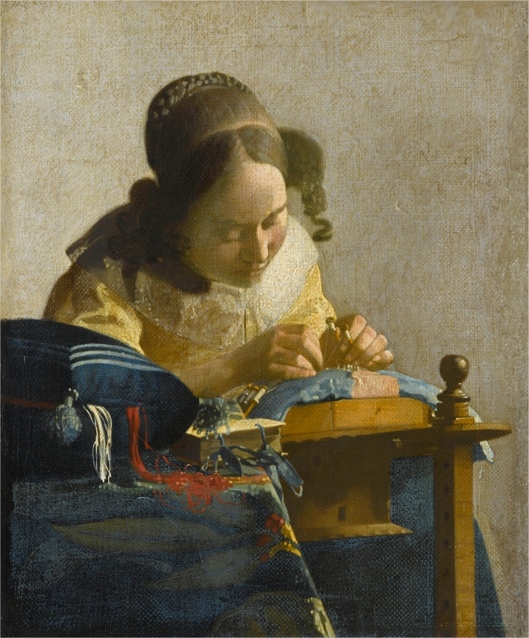Johannes Vermeer, “The Lacemaker” (c. 1670-71), oil on canvas transferred to panel (image courtesy of the Musée du Louvre, Paris)
Such sweetening might be necessary for the marketing of the show, but not for pleasure of viewing it; these are great paintings. The curators have arranged the works by subgenre, of which there are many, including women with birds, women writing letters, women with their back to the viewer, women tickling the noses of sleeping men. This arrangement allows the Vermeers to be dispersed among the other paintings, and, more important, the viewer to perceive the web of connections among the paintings, as new motifs emerge and are transformed by different artists through variations in accessories, pose, and setting.
The layout also reinserts Vermeer into the tradition in which he worked, both demystifying his paintings and lending force to his particular take on the genre. This thesis is stated visually in the first room of the exhibition, where just two paintings are displayed, both of women making lace, one by Vermeer and the other by Nicolaes Maes. The Maes came first (1655, as opposed to Vermeer’s 1670), and offers a full inventory of minutia in the life of the lacemaker, depicting her tools, her earnings (a money bag hangs under the shelf), the drab little desk at which she sits — even a calendar, marking the specific day. The painting’s surface is otter-sleek.
Vermeer, by contrast, focuses solely on the lacemaker, accompanied by her loyal sidecurls, her gaze intent upon her bobbins. Her sewing box sits in front of her, spewing threads rendered with controlled streams of red and white paint. Highlights are rendered not so much as brush strokes as brush touches, some of the daubs perfect circles that appear as little sequins of light. These, along with the visible canvas (atypical for Vermeer), give tooth to the surface. His concern is less the details of the lacemaker’s life, as with the Maes, than how her materials, and indeed her work, can thematize his subtle painterly practice.
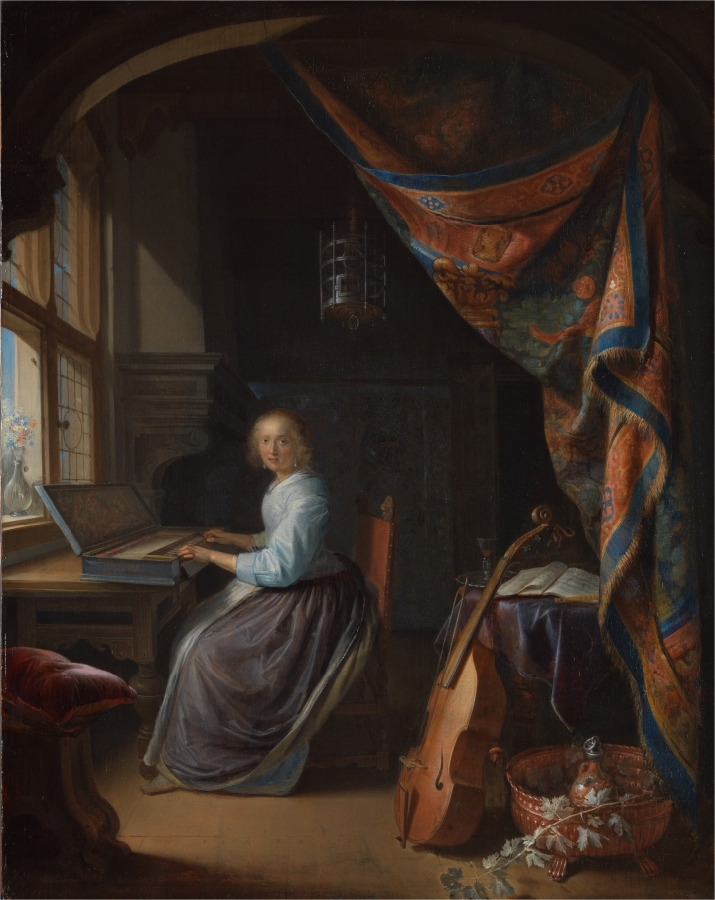Gerrit Dou, “Woman at the Clavichord” (c. 1665), oil on panel (image courtesy of the Trustees of Dulwich Picture Gallery, London)
While the Maes is no match for the Vermeer in this particular pairing, the paintings in the ensuing rooms hold their own. To match the refinement of their subjects, the artists lavish their panels with meticulous brushwork. In his “Woman at a Clavichord,” Gerrit Dou especially exerts himself in the textiles. The right-hand side of the room is dominated by a tapestry, hung from the top of the door/painting frame. It settles in heavy folds, Dou’s stippled brushstrokes following every bulge in its topography and rendering every nubbly stitch. Although the focus of the painting is the young woman at her instrument, it is the lush velvet pillow in the foreground that seems to beg, tauntingly, for the viewer’s caress.
Along with the textures of the textiles, the artists seem to have competed with each other in the succulence of their colors. I nominate for special admiration, in no particular order: the butter yellow swath of curtain in Vermeer’s “Woman with the Pearl Necklace”; the hydrangea blue of the satin skirt in Jan Steen’s “Young Woman at the Harpsichord”; the shocking white of the dress in Jacob Ochtervelt’s “The Serenade”; the spectral black drape in Cornelis Bega’s “The Duet”; and the pinkish peach, redeemed from bridesmaid dresses, of the lady’s skirt in Metsu’s stunning “Woman Reading a Letter.”
The cloth in these paintings is as vital to their appeal as frosting on a cake. But, as luxurious as the scenes are, only rarely do they stray into fantasy. The paintings are rife with the kinds of telling details that would make a short story writer twist with envy. Metsu’s “Woman Reading a Letter,” for instance, depicts holes and a few nails in the walls, presumably from previous arrangements of paintings (had they no spackle?), and, on the floor, a thimble and a single heeled shoe. I found myself drawn to the spaces under the tables, out of historical voyeurism. Where else would I find out how gentlemen arranged their feet beneath, or what kind of dross collected there?
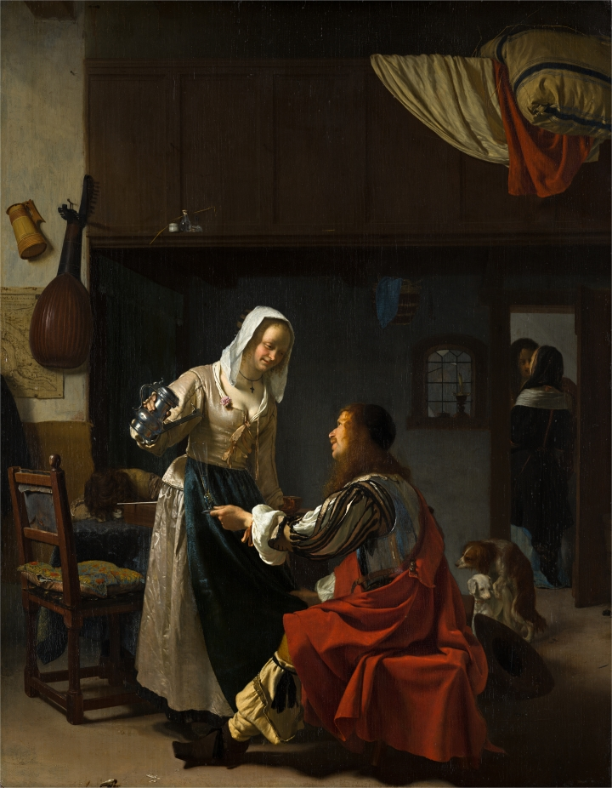Frans van Mieris, “Brothel Scene” (c. 1658-59), oil on panel (image courtesy of the Royal Picture Gallery Mauritshuis, The Hague, photo by Margareta Svensson)
As well as the subgenres identified by the curators, these paintings can be roughly divided into two broader categories: meditative and narrative. Some of the narrative works come across as highly produced gag panels, as in any of the “tickled sleep” paintings. In Frans van Mieris’s “Brothel Scene,” the setting and characters are just as elegant as the others, but a pile of bed clothes airing out in the background and a pair of humping dogs clarify the scenario. Despite this “lower” subject matter, true to the high-life sensibility, the dainty lady dog is wearing a gold necklace.
The narrative paintings are good for a chortle, but the meditative images create an echoing stillness in the viewer, as if they would facilitate some sort of psychotherapeutic self-treatment, that might also include holding a drowsy cat. This may result from the sense of interiority of many of the women, despite their near formulaic physical similarity (small jaw, delicate nose, wide brow), caused by their apparent focus on their activities. Undistracted in the small moment depicted, they are models of mindfulness.
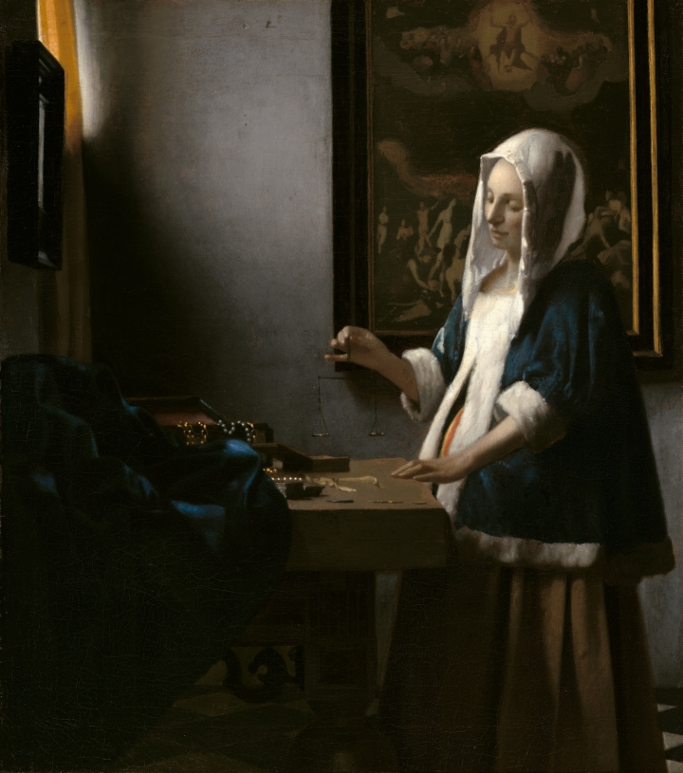Johannes Vermeer, “Woman Holding a Balance” (c. 1664) oil on canvas (image courtesy of the National Gallery of Art, Washington, Widener Collection)
In the penultimate room, another one-to-one match with Vermeer is staged, this time between the “Woman Holding a Balance” and Pieter de Hooch’s “Woman Weighing Coins” (both 1664). By this time, the paintings have demonstrated the exhibition’s thesis and then some — Vermeer is almost blending into the crowd. Both paintings portray a woman using a balance. Vermeer’s depiction is moody, the light limited, her scale empty, an image of the Last Judgment hanging behind her. Vermeer’s painting is suggestive and mysterious — custom-made to maximize interpretive musings. De Hooch’s version feels less ambitious, more easily grasped. The light is even, her scale is laden with coins, the backdrop is the tooled gold leather wall treatment favored by the very rich. As the wall text suggests, she’s just counting her wealth.
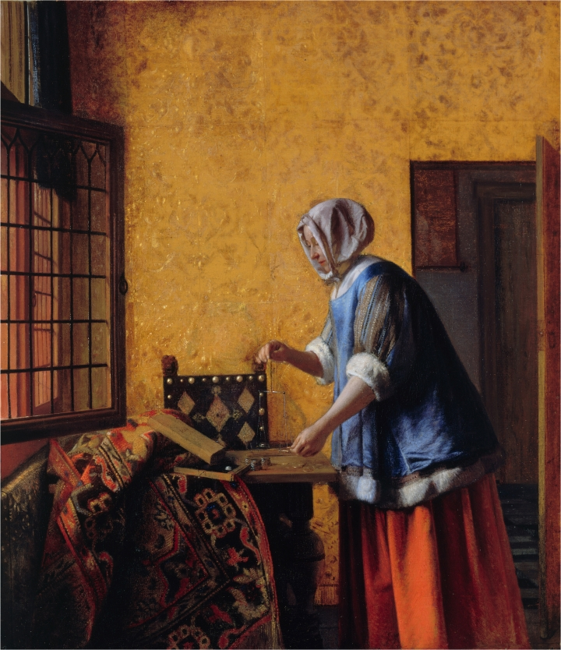Pieter de Hooch, “Woman Weighing Coins” (c. 1664), oil on canvas (image courtesy of the Staatliche Museen zu Berlin, Gemäldegalerie, property of Kaiser Friedrich Museumsverein)
To see the painting this way, however, is to read its subject without regard for how it is depicted. De Hooch was an uneven painter, but this is one of his best: the golden leather walls and the brass bosses of the chair gleam in the indirect light. How might the painting be commenting on not only the alchemy of painting, of turning mere pigment into gold, but also — with the woman effectively immured in her wealth — the very nature of the high-life genre itself? Such are the questions that can be posed through this genre, where the container of the room and its variable contents becomes a laboratory for inquiry — social, emotional, and aesthetic. As such, it parallels the exhibition itself, its own beautiful and carefully controlled discursive interior.
Vermeer and the Masters of Genre Painting: Inspiration and Rivalry continues at the National Gallery of Art (6th Avenue and Constitution Avenue NW, Washington, D.C.) through January 21.

